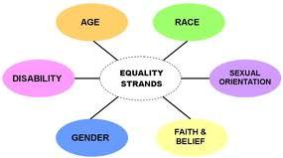

POLICY STATEMENT

The practice is committed to both eliminating discrimination and encouraging diversity amongst our workforce and in relation to our patients and service users.

The practice and its staff will not discriminate on grounds of gender, marital status, race, ethnic origin, colour, nationality, national origin, disability, sexual orientation, religion or age.

If you feel that this policy has been breached in any way, please let us know.

